March 30, 2023 |  |  | 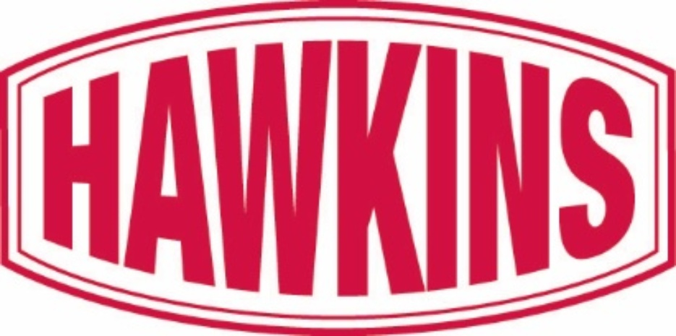
 |  |  | 
U.S. Securities and Exchange Commission  Division of Corporation Finance  Office of Trade & Services  100 F. Street, N.E.  Washington, D.C. 20549 |  |  | By EDGAR
Attn: Robert Shapiro and Lyn Shenk
Re: Hawkins, Inc.
Form 10-K for the fiscal year ended April 3, 2022
Filed May 18, 2022
File No. 000-07647
Dear Robert Shapiro and Lyn Shenk:
On behalf of Hawkins, Inc. (the “Company”), we hereby submit our response to comments received from the Staff of the Securities and Exchange Commission by letter dated March 20, 2023. For your convenience, we have repeated and numbered the comments in your letter.
Form 10-K for the fiscal year ended April 3, 2022
Management's Discussion and Analysis of Financial Condition and Results of Operations
Results of Operations
Fiscal 2022 Compared to Fiscal 2021
Sales, page 16
1.Please quantify factors to which changes are attributed, including the impact of changes in the selling prices of your products and changes in the volume of goods sold. We note you quantify bulk commodity products as a percent of sales. Please explain the importance of this to an investor's understanding of your results. Please consider quantifying increases in your sales by product lines in your segment sales discussion if important to investor's understanding. Refer to Item 303(b)(2)(iii) of Regulation S-K.

Response: We acknowledge the staff’s comment and in future filings will endeavor to provide additional detail quantifying the extent to which changes in prices or volume resulted in material changes in sales.
Our fiscal year ended April 3, 2022 (“fiscal 2022”) had 53 weeks of sales as compared to the prior fiscal year which had 52 weeks. The extra week occurs approximately every six years. The extra week in fiscal 2022 contributed approximately $17.5 million of the $177.7 million increase in sales over the prior year.
Within both our Industrial and Water Treatment segments, we disclose the percentage of our overall sales that consist of sales of bulk commodity products as these products are generally distributed and we do not add significant value to these products in comparison to our non-bulk products. Sales of these products are generally highly competitive and price sensitive. As a result, bulk commodity products generally have our lowest margins. Because non-bulk products carry higher per-unit margins, we have sought to increase our sales of higher margin products. We, therefore, believe that quantifying bulk commodity products as a percentage of sales for our Industrial and Water Treatment segments is important to an investor’s understanding of our operating results.
Our fiscal 2022 Industrial segment sales increased by $113.6 million, and we estimated the 53rd week contributed approximately $10 million of this increase. The remaining increase in revenue was driven by increased selling prices and volume. Removing the impact of the 53rd week, increased selling prices represented approximately 58% of the increase and volume increases represented 42% of the increase.
Our fiscal 2022 Water Treatment segment sales increased by $58.1 million, and we estimated the 53rd week contributed approximately $3.9 million of this increase. The remaining increase in revenue was driven by increased volume growth, including growth from acquisitions and increased selling prices. Removing the impact of the 53rd week, increased volume, both organic growth and growth from acquisitions, represented 63% of the increase, with the remainder due to increased selling prices.
Our fiscal 2022 Health and Nutrition segment sales increased by $6.0 million, and we estimated the 53rd week contributed approximately $3.6 million of the increase. The remaining increase in revenue was driven by increased selling prices offset by decreases in volume. Our Health and Nutrition segment has no bulk commodity product sales. We believe a more important measure to enhance an investor’s understanding of our results is the amount of revenue derived from manufactured products as compared to distributed products which is further detailed in the revenue footnote.
At this time, we do not believe that quantifying changes in our sales by product lines in our segment sales discussion will enhance an investor’s understanding of our results of operation. Due to our diverse product offerings and end customers, we sell similar products to different customers at substantially different prices and margins in multiple segments, depending on market conditions. As a result, we do not believe that reporting by product line would be helpful to an investor’s understanding of our operating results disclosed in the consolidated financial statements, which includes the information related to sales of our manufactured, blended or repackaged products, distributed specialty products and bulk products disclosed in Footnote 3 (Revenue) to the consolidated financial statements.
We periodically consider additional quantitative disclosures in light of applicable requirements and guidance. However, we believe that quantifying increases in our sales by product line within our segments is not necessary for investors to understand our results of operations. Further, we believe it would disclose proprietary information that would be available for use against us by our competitors.

Please contact us should there be any questions or comments with respect to the above responses.
Yours truly,
HAWKINS, INC.

 |  |  | By: |  |  | /s/Jeffrey P. Oldenkamp

Jeffrey P. Oldenkamp
Executive Vice President and
Chief Financial Officer
cc: Patrick H. Hawkins, Chief Executive Officer and President
Richard G. Erstad, Vice President, General Counsel and Secretary
Steven C. Kennedy, Faegre Drinker Biddle & Reath LLP
Joshua L. Colburn, Faegre Drinker Biddle & Reath LLP

